Deck of Cards Assignment DUE Wednesday, April 24
Name: Daniel Voznyy
Answer the following questions. Type your answers in this document in MS Word and hand in
A client Code
- What is the identifier for the new instance of the DeckofCards class?
- The identifier is “deck1”
a) Is any data being passed to the constructor?
- No data is passed in the constructor.
2. Explain what happens when deck1.deal() is placed in a print statement. Mention a few things that
happen (not just one). Refer to the code for the other classes.
- When deck1.deal() is placed inside a print statement, .deal() runs on that DeckofCards object, and returns a Card from that deck’s array.
- When the card is printed out, its overridden toString() method gets called automatically, which it uses to print out its face and suit in a short message.
B Card class
1. What is being assigned in the constructor?
- The card’s face and suit
2. Explain what the toString() method does.
- The toString() method is used to return a string message when it is needed from the card. Without this override, Java simply returns the class’ name and an index the computer uses for that object (e.x. Card@5cad8086)
C DeckofCards class
1. Explain the line of code: myDeck[n] = new Card( )
- This code sets the card at the index of n in the myDeck array to a new card, with parameters passed into it based on N, in a way that defines the card’s face and suit.
- What do you think is being stored in myDeck[ ]?
- Card objects
- What two features does each element in myDeck[ ] have?
- A face and a suit
- How does use of array improve the functionality of the program?
- We do not need to create 52 individual card objects and assign their faces and suits manually, we can just store them as a list in the array, and automatically generate their faces and suits.
2. Why does the constructor have a for loop? Explain.
- It automates the process of card creation
a) the purpose of [n % 13] in the faces[ ] array
- Get the remainder of 13, which inside the loop returns numbers from 0 to 12 as we go through the loop. These values are used to assign a face to the card, since there are 13 faces, and each suit simply repeats these faces.
b) the purpose of [n / 13] in the suits array.
- Set the suit. The division is done on integers, so it is rounded down to its nearest number, which increments by 1 ever 13 iterations. i.e. once we go through all the faces of a suit, we are to move onto the next suit.
4. What is the return type for the deal() method?
- The return type is Card
a) What is the purpose of the if statement?
- Avoid an IndexOutOfBounds exception, and signify that we’ve gone through all cards in the deck
5. Usually before playing a card game the deck must be shuffled. Describe in words a process that
could be used to create a “shuffle method”.
- Go through each card “slot” in the deck, and swap it with another card randomly.
6. Write your own “shuffle” code. 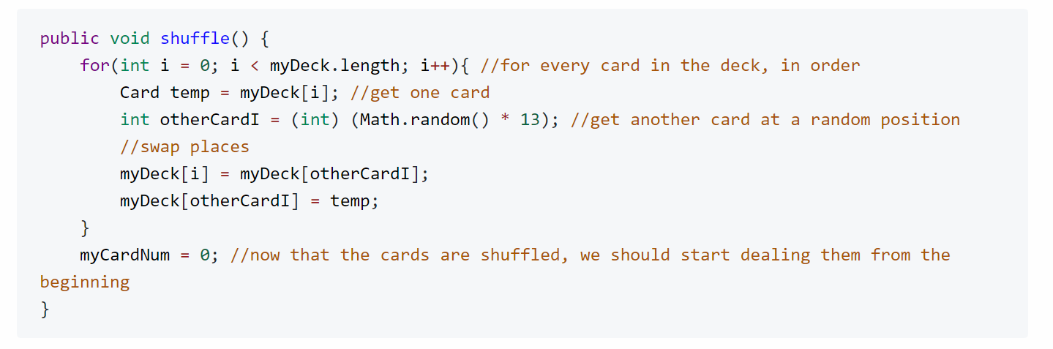
7. Submit your typed answers along with a fully working code (Test it!) which includes “shuffle method.
Print the shuffle method and include in your submission.
Drop off modified code to include your own shuffle method.
Total marks:_________ / 20 (K/C) ________ /15 (A)

